Setting up Insightedge -Kubernetes cluster with minikube on windows 10 local laptop

Contents

0) Enable VT-X in UEFI 2

1) Install Virtual box 2

2) Open PowerShell with Admin privilege (tip: recommend using PowerShell due to lot of online tips available.) 2

3)Disable Hyper-V 2

4) Open PowerShell with Admin privilege if you restarted your system, run next steps 2

5)Install Chocolatey Package Manager (https://chocolatey.org/install) 2

6) Install minikube (tip: virtualized environment for running single cluster Kubernetes) 2

7) Install Kubernetes cli (tip: Client tool to interact with Kubernetes cluster) 2

**8)** Install Helm (tip: Package manager for Kubernetes) 2

9) Install Insightedge(*Note: milestone version :14 to be released in Nov 2018*) 2

10) Start minikube: 3

11) Submitting Spark job 3

12) Stop minikube 3

13) Delete kubernetes cluster 4

**14)** Troubleshoot tips 4

a. Make sure you have the right version 4

b. Error restarting cluster:restarting kube-proxy:waiting for kube-proxy to be up for configmap update: timed out waiting for the condition 4

15) To Enable Hyper-V back run below command in PowerShell 4

# Enable VT-X in UEFI

tip, if the UEFI screen flashes too fast or gets skipped, on Windows 10, you can try running shutdown /s /t 0. Windows 10 does a hybrid shutdown, it doesn't fully shutdown and enables a quicker startup.

# Install Virtual box

<https://www.virtualbox.org/wiki/Downloads>

# Open PowerShell with Admin privilege (tip: recommend using PowerShell due to lot of online tips available.)

# 3)Disable Hyper-V

Disable-WindowsOptionalFeature -Online -FeatureName Microsoft-Hyper-V-All

*This needs a restart of the system*

# 4) Open PowerShell with Admin privilege if you restarted your system, run next steps

# 5)Install Chocolatey Package Manager (<https://chocolatey.org/install>)

Set-ExecutionPolicy Bypass -Scope Process -Force; iex ((New-Object System.Net.WebClient).DownloadString('https://chocolatey.org/install.ps1'))

# 6) Install minikube (tip: virtualized environment for running single cluster Kubernetes)

1. choco install minikube
2. minikube version
3. minikube docker-env | Invoke-Expression (start docker insider kubernetes)

# 7) Install Kubernetes cli (tip: Client tool to interact with Kubernetes cluster)

1. choco install kubernetes-cli
2. kubectl version

# **8)** Install Helm (tip: Package manager for Kubernetes)

1. choco install kubernetes-helm
2. helm version

# 9) Install Insightedge(*Note: milestone version :14 to be released in Nov 2018*)

<https://gigaspaces-releases-eu.s3.amazonaws.com/insightedge/14.0.0/gigaspaces-insightedge-enterprise-14.0.0-m12-b19912.zip>

# 10) Start minikube:

1. minikube --memory 10000 --cpus 3 start --v=7

(tip:7 indicates the log level this is helpful for debugging purpose during start up)

1. kubectl cluster-info
2. helm init
3. minikube dashboard
4. kubectl create serviceaccount spark
5. kubectl create clusterrolebinding spark-role --clusterrole=edit --serviceaccount=default:spark --namespace=default
6. Install InsightEdge (Note: **goto insightedge installation charts directory which contains yaml config file for deploying insight edge.)**

helm install insightedge --name insightedge-space

1. kubectl get services : to display the services runnings

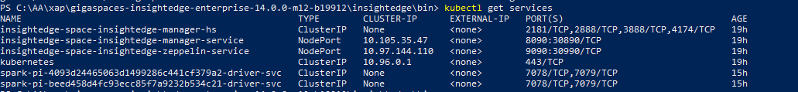

# 11) Submitting Spark job

**Add** "C:\Windows\System32" in 'PATH' variable of System Variable for windows users

C:\AA\xap\gigaspaces-insightedge-enterprise-14.0.0-m12-b19912\insightedge\bin>insightedge-submit.cmd --master k8s://https://192.168.99.100:8443 --deploy-mode cluster --name spark-pi --class org.apache.spark.examples.SparkPi --conf spark.kubernetes.authenticate.driver.serviceAccountName=spark --conf spark.kubernetes.container.image=gigaspaces/insightedge-enterprise:14.0.0-m12 local:///opt/gigaspaces/insightedge/spark/examples/jars/spark-examples_2.11-2.3.1.jar

Tip: to get container image run docker images

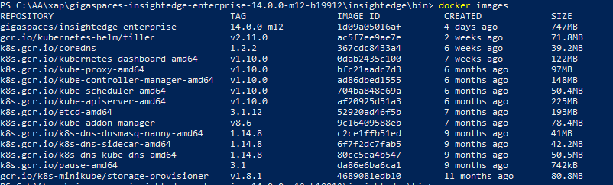

# 12) Stop minikube

minikube stop

# 13) Delete kubernetes cluster

minikube delete

# **14)** Troubleshoot tips

### Make sure you have the right version

* 1. **kubectl version --short**

**Client Version: v1.10.3**

**Server Version: v1.10.0**

### Error restarting cluster:restarting kube-proxy:waiting for kube-proxy to be up for configmap update: timed out waiting for the condition

* 1. Close the VirtualBox if opened
  2. Delete the previous tempfiles generated (c:\users\Dharma\.minikube,.kube
  3. If you are behind the proxy set the proxy
  4. Then do the following
     1. Minikube stop
     2. Minikube delete
     3. Restart your system

# 15) To Enable Hyper-V back run below command in PowerShell

Enable-Feature:Microsoft-Hyper-V /All